**World Weather Analysis**

**Summary**

* I created a set of 2000 random longitudes and latitudes using the code np.random.uniform.

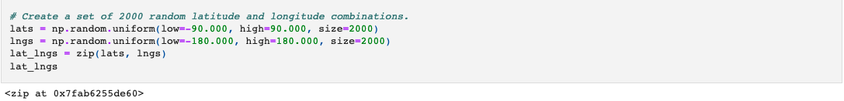

* Using the 'citipy' module in Pandas, the coordinates were used to find the nearest city. If no city was found near to the random coordinates they were disregarded. The search yielded a total of 734 cities.

[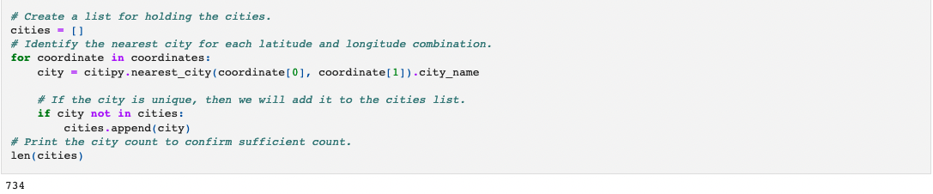](https://user-images.githubusercontent.com/104115586/173446381-ced1e9f0-67a4-43e9-b3b0-7f95db949055.png)

* The user is prompted to input their preferred temperature at the destination. This information is used to create a new DataFrame with only cities within that temperature range.
* The best hotel that matched my input was the “Salt of Palmar” in Quatre Cocos.

